CS 340 README Template

Use this template to complete your README file. When completing the template, keep the headings as they are so that your document has a clear organization. Remove the italicized prompt text after you have completed each section for a polished final document.

About the Project/Project Title
This project is a Python-based CRUD module designed to make it easy for users to manage animal shelter data stored in a MongoDB database. This module allows the user to create new records, read existing records, update stored information, and delete records as needed.

Motivation
The motivation behind this project was to make it easier to manage shelter data by providing a simple Python module that allows the user to create, read, update, and delete documents in the MongoDB environment.

Getting Started
The first step in the project is to import the Austin Animal Center (AAC) Outcomes data set into MongoDB and then create a user account.
- Open up a terminal session and navigate to the datasets folder.
- Upload the CSV file aac_shelter_outcomes.csv into MongoDB using mongoimport:
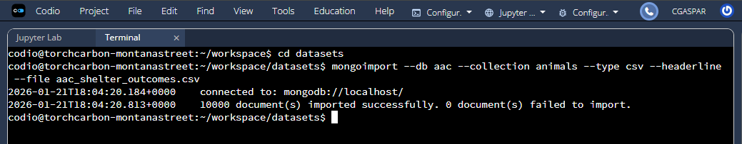
- Open the Mongo shell using mongosh and create a user account with read/write access:
use admin
db.createUser({user: "aacuser", pwd: passwordPrompt(), roles: [{role: "readWrite", db: "aac"}]})
- After running the command above, you can connect to the aac database and run the command below to verify that the account has been created successfully:
db.runCommand({connectionStatus: 1})
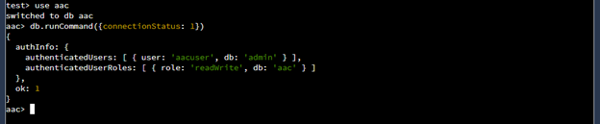

Installation
To use this Python module, you will need the following tools:
- Python 3.10+ - Required to run the module. Install from python.org.
- MongoDB – To access the database. Install from mongodb.com.
  - This project uses MongoDB as the database to store all of the animal shelter data. MongoDB was chosen since it makes it easy to store and work with data. It also works well with Python, allowing the program to quickly get, query, and update data from the database.
- Dash – Used to create the dashboard. dash.plotly.com
  - Dash is a Python framework used to create interactive dashboards. It allows you to represent data in different forms, such as tables, charts, and maps, and allows users to interact with the data through radio items, buttons, and dropdowns. Since this project already works with Python, Dash was the best choice.

Usage
NOTE: Make sure you configure the MongoDB connection and user account credentials in the Python file.
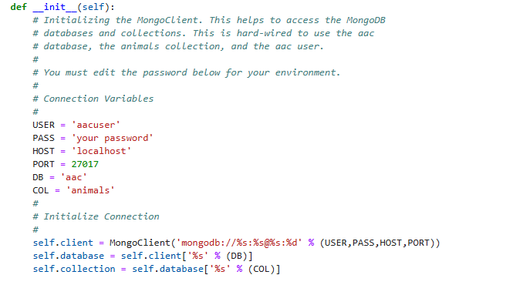

Importing the CRUD module:
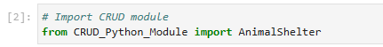

Instantiating an instance of the class (NOTE: the credentials should be stored in the Python file):
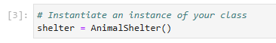

Using the create function to create a new record in the database. Print create result to make sure that the entry was created successfully:

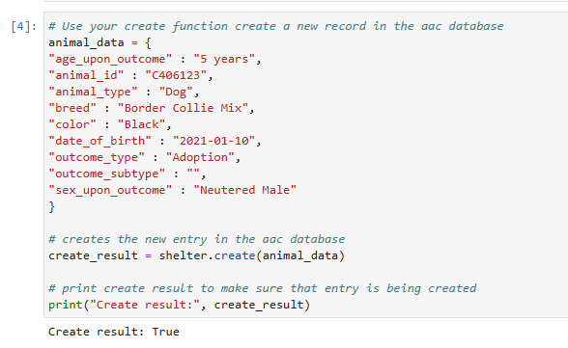

Testing the read function, querying the Dog animal type. The results will display entries with the animal type of Dog:
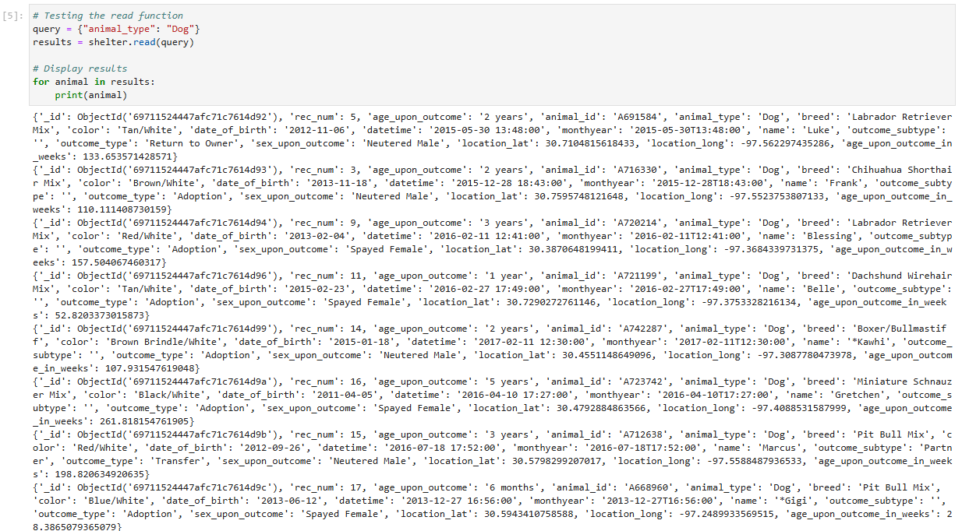

Testing the update function, querying for the recently created record and updating the breed and color:
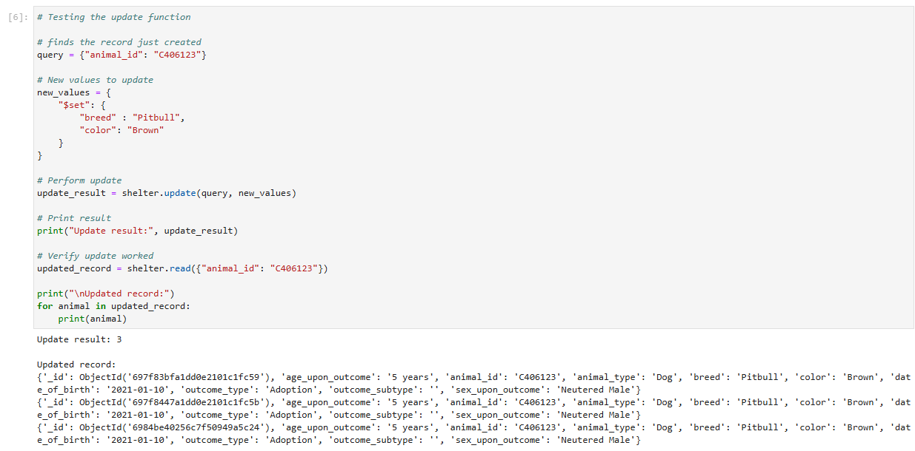

Testing the delete function, querying for the recently create record and deleting it. Verifying that the record was deleted successfully:
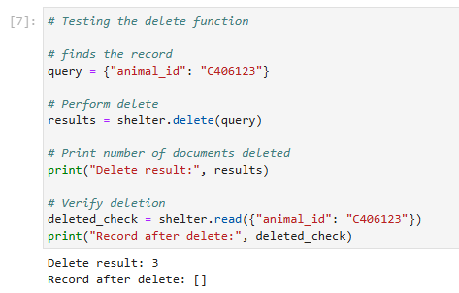

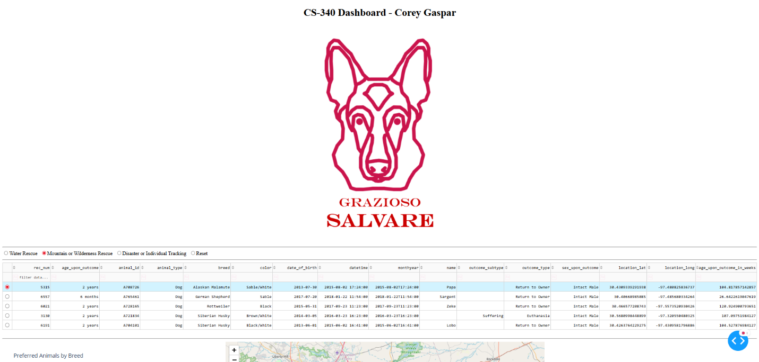

When water rescue is selected, the table and chart will display any dogs that are Labrador Retriever Mixes, Chesapeake Bay Retrievers, and Newfoundlands, intact female, and have a training age between 26 weeks to 156 weeks.
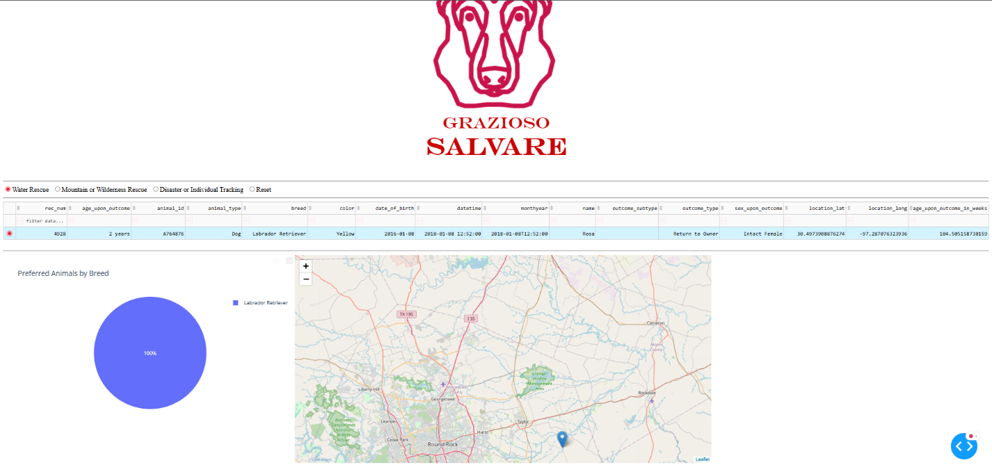

When clicking on Mountain or Wilderness Rescue, the table and chart will display all dogs that are German Shepherds, Alaskan Malamutes, Old English Sheepdogs, Siberian Huskies, and Rottweilers, intact males, and have a training age between 26 weeks to 156 weeks.
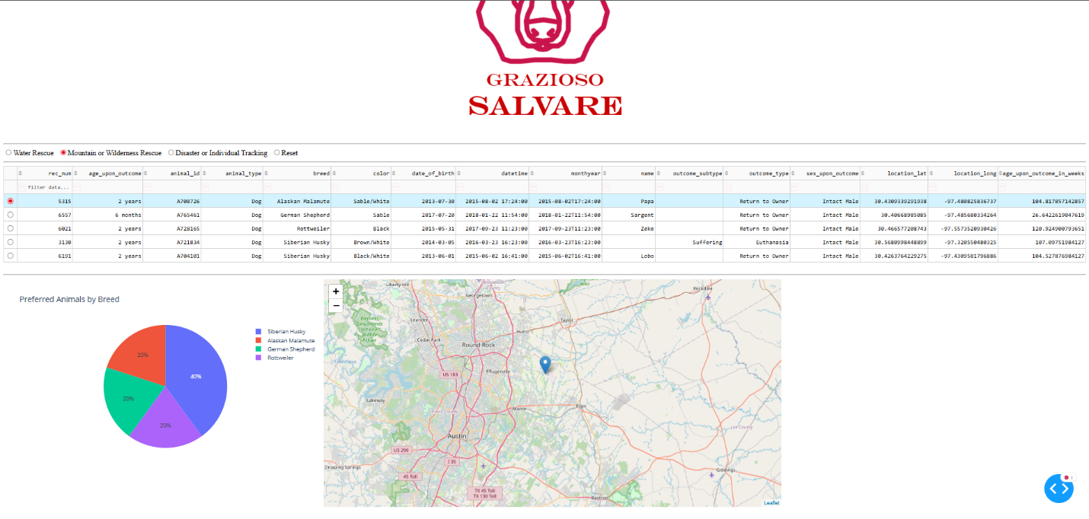
When clicking on Disaster or Individual Tracking, the table and chart will display all dogs that are Doberman Pinschers, German Shepherds, Golden Retrievers, Bloodhounds, and Rottweilers, intact males, and have a training age between 20 weeks to 300 weeks.
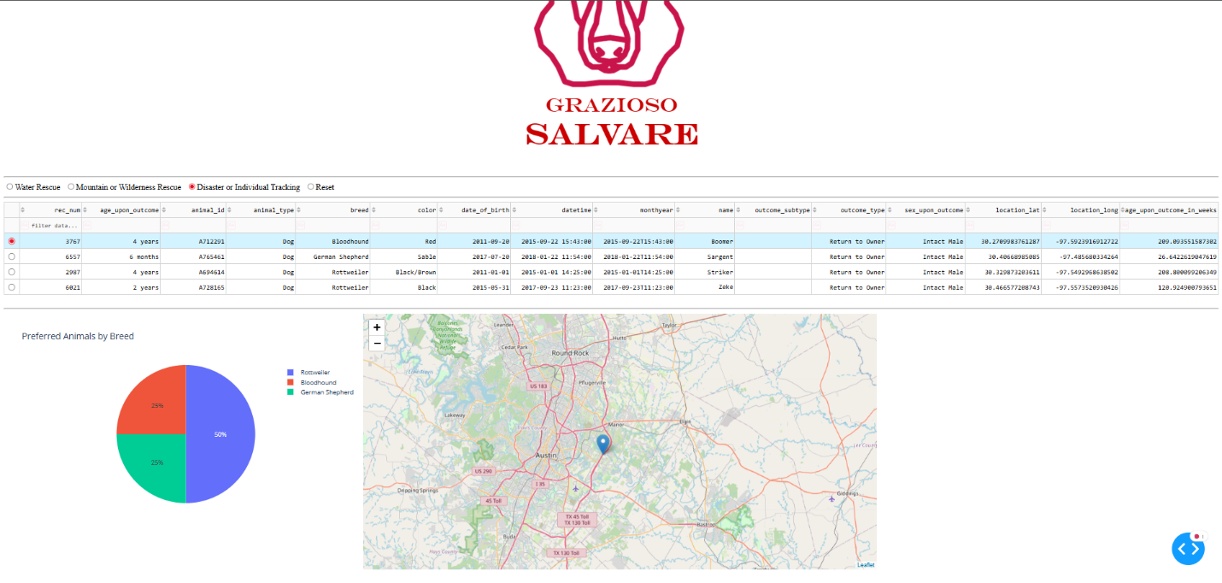

When clicking on Reset, the table and chart will display all entries in the database.
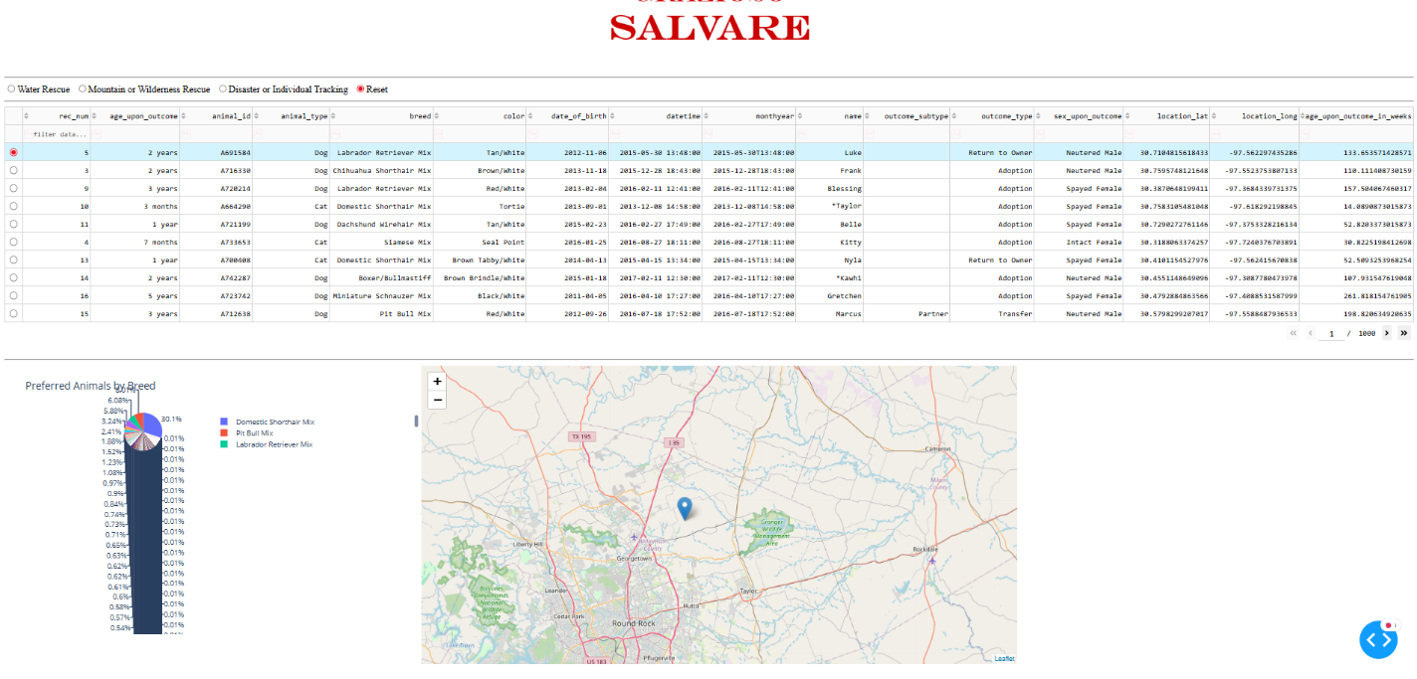

Challenges
The biggest challenge I faced in this project was querying the database correctly. When I first toggled through the radio items in the table, the dashboard would show the correct breeds for each type of rescue, but it also included dogs with the wrong training age and sex. The queries I created weren’t strict enough. To fix this, I added “sex_upon_outcome” to filter through the preferred sex and added “age_upon_outcome_in_weeks” to filter by training age.

Contact
Corey Gaspar

